

Piri AI: AI-Supported Academic Writing Tool for
Research and Content Creation
Piri AI is an AI-powered content creation tool that provides a unique writing and research support experience for academic work. Equipped with generative AI technology, this tool is designed to accelerate and enhance the efficiency of content creation processes for researchers, students, and academics.
Here are the standout features of Piri AI:

Intelligent Keyword and Alternative Generation
Piri AI takes the keywords or short sentences provided by users and generates alternative keywords from these inputs. This process is carried out using AI-supported algorithms, offering users a broader range of research opportunities. Thanks to these alternative keywords, users can discover sources from different perspectives on the topic, thereby expanding the scope of their research.

Publication and Content Summarization
Piri AI uses the keywords entered by the user and the alternatives it generates to locate relevant academic publications. These publications encompass millions of works from various disciplines and publishers. Piri AI scans these sources and creates an original piece between 500 and 500 words, tailored to the user's needs. The content is derived from the summaries of the selected sources and is structured in accordance with relevant academic standards.

Automatic and Structured Citation Generation
Piri AI not only writes content but also ensures accurate and structured citations for the sources used. This feature provides great convenience for academic work. Users can choose from 10 different reference formats (APA, MLA, Chicago, etc.) and ensure that citations are correctly formatted.

Flexible Content Editing
Piri AI allows for flexible editing of the written content. Users can expand or shorten any paragraph in the generated text. This feature is especially advantageous when new ideas emerge during research or when unnecessary information needs to be reduced.

Research Expansion and Question Suggestions
Piri AI offers AI-supported question suggestions to help users expand their research. These suggestions are designed to assist users in gaining deeper insights and refining the direction of their research. This feature is particularly beneficial in thesis writing or preparing comprehensive academic articles, as it helps researchers develop new ideas and approaches.

Multilingual Support
Piri AI has the capability to generate content in five different languages, including Turkish and English. This provides a significant advantage for users whose native language is not Turkish.

Easy Export and Sharing
All content created with Piri AI can be easily exported to .docx formats. This accelerates the process of writing and sharing academic papers, allowing users to directly edit and utilize the work they have created.

Detailed Information on Resources
Users can easily access the sources used by Piri AI. By clicking on any source, they can navigate to it directly. This feature helps users better understand the sources and see which information contributes to their work.

Detailed Information on Sources*
Piri AI expands access by scanning a wide range of databases.
  - While generating text, Piri AI not only utilizes the databases subscribed to by your institution but also incorporates open-access resources, enabling access to a much broader range of content.
  - Piri AI includes the National Thesis Center of Turkey (YÖK) as well as master’s and doctoral theses from thousands of international universities.
  - Piri AI is not limited to digital databases; it also integrates with library catalogs. This allows the generated texts to utilize both digital and print resources.
  - Piri AI goes beyond traditional text-based databases by incorporating video databases as well.
* Publications with summaries and/or full texts are included within the scope of Piri AI. Summaries of books must be available within the catalog.

User-Friendly and Fast
Piri AI features a user-friendly interface that combines speed and efficiency in the content creation and editing process. Content aligned with academic standards can be prepared quickly and with minimal effort. While saving researchers time, Piri AI enables them to manage the writing process without compromising on academic quality.


Piri AI: Screenshots
Figure 1. Piri AI Writing Start Page
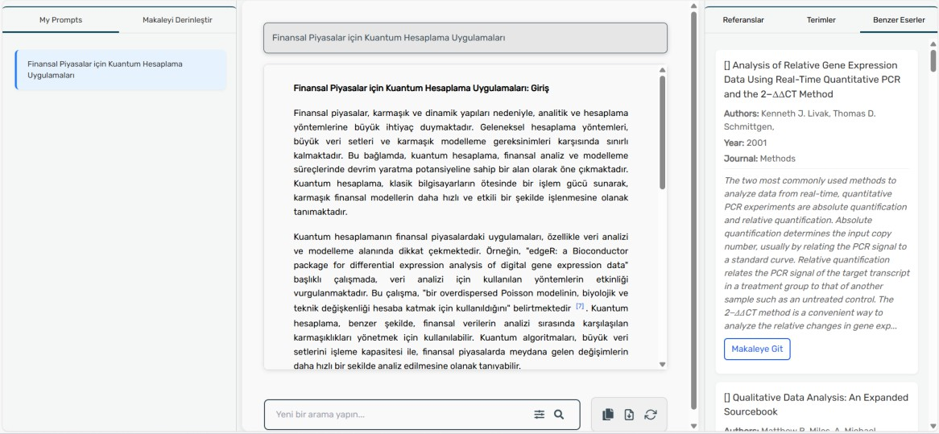
Figure 2. Search Query Result
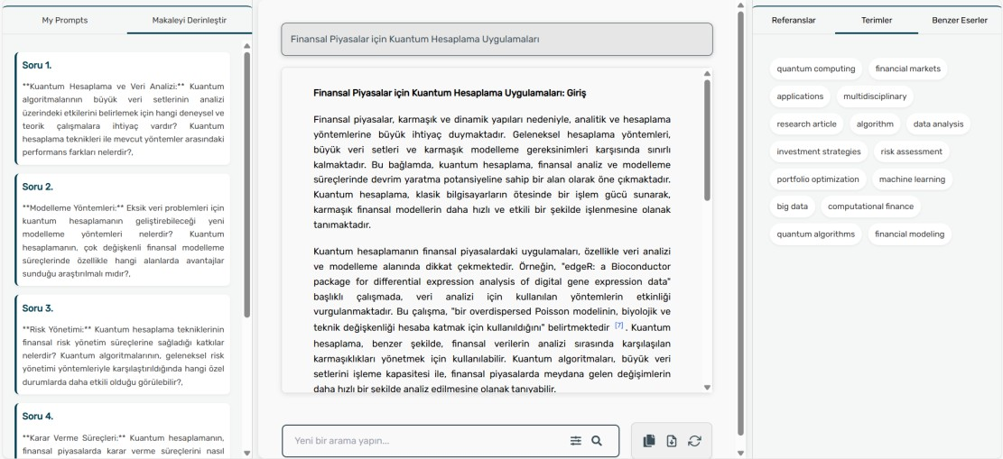
Figure 3. Term and Article Deepening Screens
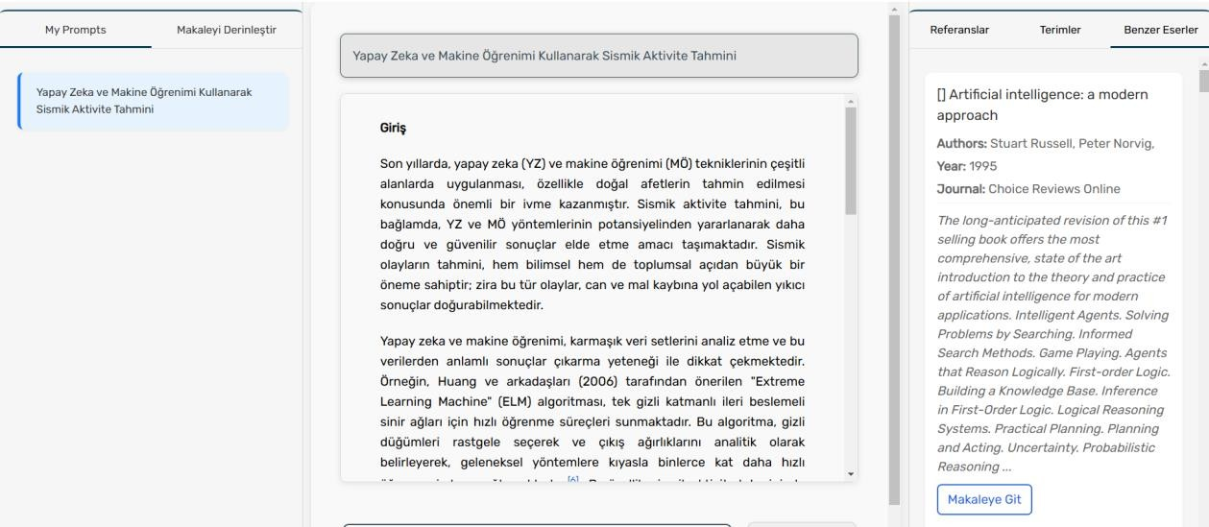
Figure 4. Display of Similar Publications

